
CRANLEIGH GARDENS
WINTER 2025

MEDICAL CENTRE

Staff Update
HCA Keilee and Practise Nurse Kayleigh have returned from maternity leave.
Dr Olivia Woods has recently started her maternity leave with her baby boy, and we look forward to her return later this year.
We are soon to have some new GP Registrars; Dr Nurudeen Akindele, Dr Melissa Addo and Dr Jaehee Pyon.
They will be joining Dr Vanessa Agosti, Dr Keerthi Menon, Dr Ade Ojoawo and Dr Mina Saeed who some of you may have already met.
Staff Update Seasonal Flu Vaccination Diabetic Group Clinics
Cranleigh Gardens Medical Centre
Cranleigh Gardens,
Bridgwater
TA65JS
Surgery 01278 433335
Prescription Line 01278 427092

Welcome to the latest instalment of the Cranleigh Gardens Newsletter


At Cranleigh Gardens Medical Centre and Westonzoyland Surgery, our aim is to provide our patients with the highest quality of healthcare services and resources.
The main surgery is open Monday – Friday 8.00am – 6.30pm including phone lines. Our Westonzoyland surgery offers a closer to home service for those living in the area, with doctor appointments every Monday and phlebotomist appointments every other Monday.



For patients who work Monday – Friday and struggle to make appointments during the week, the Partners hold one Saturday clinic a month at the main surgery to guarantee everyone is provided with the same service.

PRESCRIPTION AND TEST RESULT LINE
When calling for test results, please wait until after 2pm to help staff manage with the volume of calls in the mornings.
When you need to order your repeat prescriptions, please call 01278 427092 between 9.30 – 12.30 Monday to Friday.

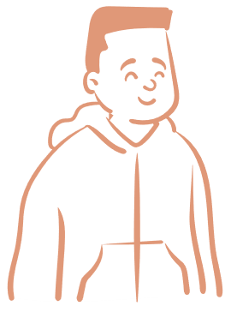
THE NHS APP

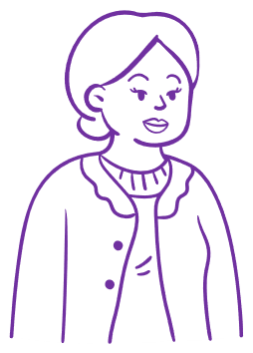
How Do I Use It?

To gain full access to the NHS App, you will need to ask at Reception for the online services form with some photo ID. Once you have been emailed your log in details you will be able to connect it to the surgery.

What Can I Do?

Once you are connected, you will be able to view test results, see and cancel appointments, order your repeat medication and much more.

Who Can Use It?
Everyone and anyone can use it. Parents can add children under 13 years old to their accounts and Carers can have access as a proxy user for a person they care for. Make sure to ask at Reception if you need help setting up.



CANCELLATIONS
Did you know you can cancel your appointments without speaking to someone?
Just use the automated cancellation line when phoning in.
This will help lower the number of incoming calls for our Reception Team and make your life easier too.
Remember your appointment can be offered to someone else so please remember to cancel in plenty of time.
You can also cancel your appointment via our website or by using the NHS app.

PRESCRIPTIONS
Did you know there’s more than one way to order your repeat prescriptions?
- Prescription Line
- Forms in Reception
- NHS App
- Emails
- Our Letterbox
Please allow our team 2 working days to get your prescription over to the pharmacy and remember to order them in plenty of time.
As some of you may now be aware, we are no longer sending the initial confirmation when booking appointments.
Instead, we are sending a reminder 3 business days before the date of the appointment so make sure you are making a note when booking in.
We are still offering Flu Vaccinations for those who are eligible for one.
If you have yet to have yours and are interested in having one, please contact Reception to book in for an appointment.
If you have had yours, please make sure the surgery is aware and if you are unsure whether you are eligible do not hesitate to call.


DIABETIC GROUP CLINICS

Share your experience and gain knowledgeable insight, while still getting your 1-2-1 review. For more information, search Diabetic Group Clinics on our website, or call us using option 5.
Our aim is to help you manage your diabetes better with the help of our Diabetes Nurse Lucy, Health Coach SJ, Facilitator Genna and of course, support from your peers.
These clinics are held at Cranleigh Gardens Medical Centre, Westonzoyland Surgery and Victoria Park Health and Wellbeing Hub. When booking your appointment, you will have the selection of all three to choose from.
This month we have launched our new Diabetic Group Clinics with the aim to reducing the wait time for your diabetic reviews.


BLOOD TESTS BOOKED VIA LINK 105
FLU VACCINES BOOKED VIA LINK 930
RESPIRATORY APPOINTMENTS 208
HEALTH COACH APPOINTMENTS 116
PHYSIO APPOINTMENTS 274
INBOUND CALLS RECEIVED 28150
INBOUND CALLS ANSWERED 22305
OUTBOUND CALLS MADE 17562
CALLBACKS REQUESTED 137

1st October – 31st December
STATISTICS

